Restoring the Balance: A Mindful Approach to Managing Self
The following offers a summary of a mindfulness programme preciously delivered to University of Edinburgh Business School students. The programme covers 7 key topics, each of which introduces and explores mindfulness concepts (using the acronym BALANCE) and shares tools and resources which can help manage stress and overwhelm.

E is for Enough!
Do you have high expectations of yourself and others? There's nothing wrong with wanting to grow, to develop and improve ourselves but the problem with expectations is that they usually lead to disappointment. We can often feel that we haven't reached the high standards we set ourselves (or those we believe others have set for us - whether they actually have or haven't is irrelevant). And the same is true when we have expectation of others - if they don't deliver, we feel let down.
Each of the previous units in the Balance programme has explored a different mindful concept but they share a common purpose - to allow us to explore and connect with ourselves, to develop an understanding of who we really are.
And who we really are is..... enough!

For each of us, we will experience that feeling of not doing, having or being enough at different points and in different areas of our lives; Do I have enough time, enough money, enough ability? Am I clever enough, happy enough, hard-working, liked or loved enough?
Each of these questions can leave us feeling dissatisfied and, for each of them the solution is the same: Self-love.
Now let's be clear, self-love does not mean narcissistic self-obsession. It means paying attention to ourselves with acceptance and self-compassion. It means letting go of those internal stories that don't serve us. It means being who we are and knowing that who we are is.....enough!

E is also for .....Energy
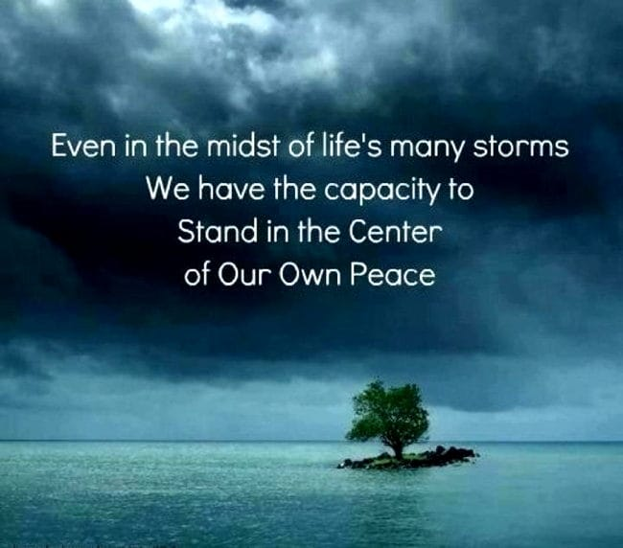
Now that you have navigated through the Balance programme you will have had many reflections and insights. In order to continue to grow and develop, consider where you will focus that energy because, as we learned when we explored attention, whatever we focus our energy on will grow. Setting intentions (just like the archer aiming for the bullseye) is a great way to harness our energy and a really useful starting point is to tap into what is already there. Each of us has an innate sense of peace within us. It can sometimes feel hard to connect with it but the good news is we don't have to try too hard. In fact, trying too hard is a sure way to miss the target. Simply allowing ourselves to slow down, to be quiet and to be still creates the conditions where we can connect with our inner peace. That sense of peace is always available to us, waiting for us to simply allow it to emerge.
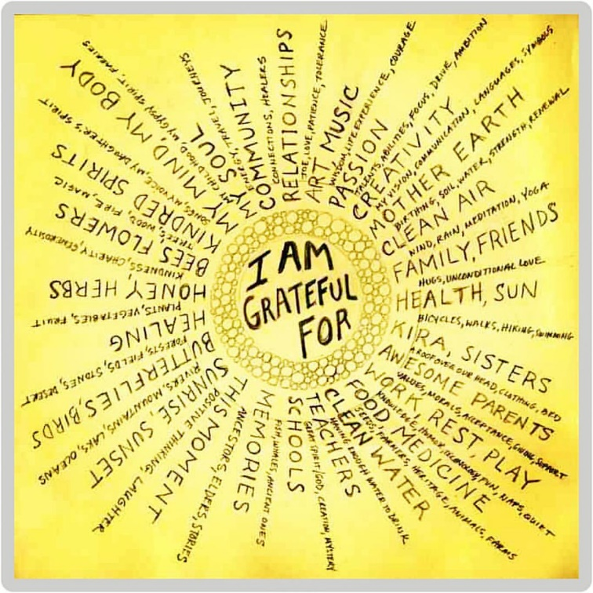
Activities:
Practice Gratitude: Each evening, before you go to sleep think of three things you are grateful for, considering the following:
  - What am I grateful for about myself (e.g. my talents, abilities, insights etc)
  - What did I do today that I am grateful for?
  - What (or who) do I have in my life that makes me grateful?

Additional Resources
- Check out this lovely video where Buddhist nun Gen Kelsang Nyema poses three simple yet powerful questions https://www.youtube.com/watch?v=xnLoToJVQH4
- Melissa Camara Wilkins shares her thoughts on what it means to be enough in this engaging blog.
- And have a look at this article on how practicing gratitude can change your brain, based on research conducted with predominantly college students.

