Restoring the Balance: A Mindful Approach to Managing Self
The following offers a summary of a mindfulness programme preciously delivered to University of Edinburgh Business School students. The programme covers 7 key topics, each of which introduces and explores mindfulness concepts (using the acronym BALANCE) and shares tools and resources which can help manage stress and overwhelm.

C is for Compassion
Definition: Compassion literally means “to suffer together.” Among emotion researchers, it is defined as the feeling that arises when you are confronted with another’s suffering and feel motivated to relieve that suffering.

As we practice mindfulness, we cannot help but become more aware of what is going on in our internal and external world. This growing awareness brings insight into suffering - our own and that of others and, as we become more aware we are compelled to respond, through cultivating compassion.

However, can we practice compassion without first cultivating self-compassion?
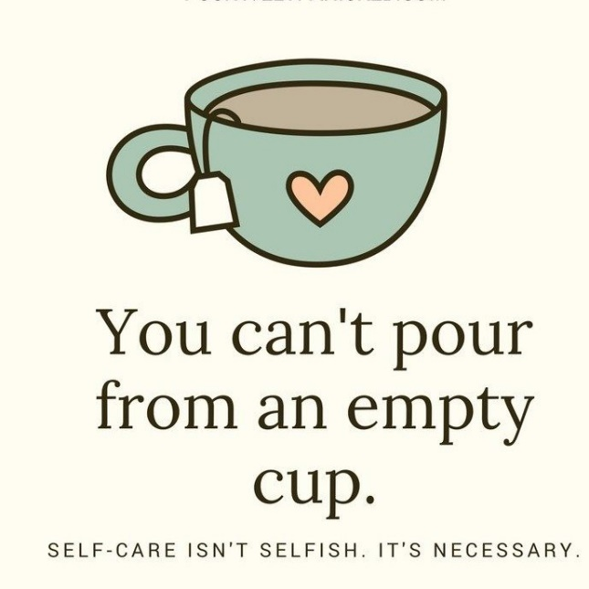
Some belief that this is possible for a time but eventually we will burn out, experiencing what has been described as compassion fatigue, where we feel we cannot give any more or find it difficult to maintain that sense of caring (more on this below). It's an aspect of our minds attempting to look after us - shutting out the pain, numbing our senses and emotions when we feel overwhelmed. It is also why self-care, self-compassion is so important!
But many of us struggle with this notion of self-care, viewing it as self-indulgence, egocentric and uncaring for others.
If this is the case for you, take a moment to reflect on where this belief may have come from and what impact it has had on your ability to show yourself compassion.

Kristen Neff, one of the leading writers on self-compassion has developed a model, which includes these three concepts:
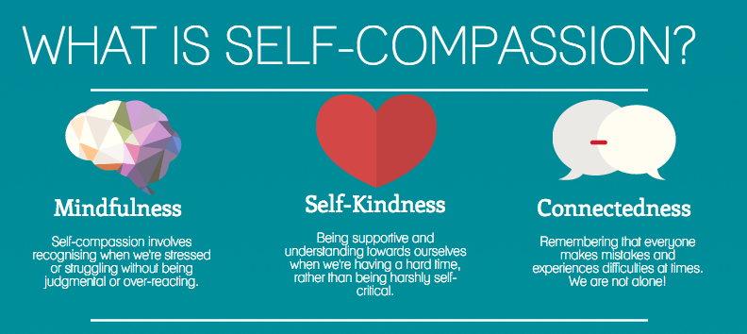
C is also for ....curiosity. or connection????
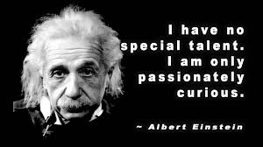
Being mindful in the present moment is about having a sense of curiosity about what is there. We are not trying to change what we find (at least not initially). It is not about manufacturing a false sense of 'bliss' or happiness. It is about exploring, with curiosity and compassion, all that we are - warts and all! This can be a challenge if we don't especially like what we become aware of - our thoughts, feelings and behaviours.
And this is why self-compassion is so essential in our mindfulness practice.
Activities:
- Thinking about the definition of compassion above, is there someone you know is going through a difficult time that you could connect with? A phone call, a letter or, if able, arranging to meet for a coffee and a chat?
- Why not try out Kristen Neff's self-compassion test, which also includes links to self-compassion practices and exercises.
- Linking to the last session on 'the Narrator', pay attention to what you are saying to yourself when you are going through a difficult time. Is the narrative compassionate or critical? If the latter, what could you say instead? Journal anything that arises.
Additional Resources
- Check out this article on compassion fatigue, which also touches on trauma and burnout.
- Daniel Goleman, author of "Emotional Intelligence," asks why we aren't more compassionate more of the time in this Ted-Talk
- In this Youtube clip, The Differences Between Mindfulness & Self-Compassion. Dr. Christopher Germer co-developed the Mindful Self-Compassion Program with Kristin Neff. In this video, he explores the similarities and differences between mindfulness and self-compassion, which many people get confused about.
- Some great books on mindful compassion:

  - Self-Compassion: Stop beating yourself up and leave insecurity behind (Kristen Neff)
  - The Mindful Path to Self-Compassion (Christopher Germer)
  - Mindful Compassion (Paul Gilbert and Choden)
