Restoring the Balance: A Mindful Approach to Managing Self
The following offers a summary of a mindfulness programme preciously delivered to University of Edinburgh Business School students. The programme covers 7 key topics, each of which introduces and explores mindfulness concepts (using the acronym BALANCE) and shares tools and resources which can help manage stress and overwhelm.

N is for....the Narrator!


Think about the stories you tell yourself.
Do you invest your time, your energy and your belief in them (and by doing so you are making them stronger?) In doing so you are constantly reinforcing the narrative that then guides your future thoughts and actions. In this way the story becomes a cycle, each time you tell it, you believe it as your truth - and it tends to define who you are and how you respond to life's situations.
Is the story actually true or is it based on perception, assumption and (perhaps false) belief?
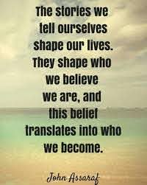
Impostor syndrome, comparison and the words of others whose opinions we value can shape the stories we tell ourselves -and once we've started to listen to our internal narrator, we find 'evidence' to reinforce the story we are telling - what we describe as confirmation bias , which serves to perpetuate what we believe.
And this isn't just about ourselves - we form stories about others, usually shaped by our own internal view of ourselves. This is where comparison comes into its own - we either think we are somehow 'better' than others or, more often than not, 'worse' than others in some way.

What if the story we are telling is a good story?
So, it might not be all doom and gloom. We may be investing our attention and energy in positive stories. There's a lot of wisdom in the notion of listening to our inner voice, our intuition and if what we are telling ourselves builds us up, rather than bring us down, then maintain that focus.
However, one of the brain's overarching guiding principles is to move away from threat -therefore, we are dealing with a default mindset. If we are looking for what might go wrong, what might be problematic, we will probably find it (as Henry Ford points out in the quote above).
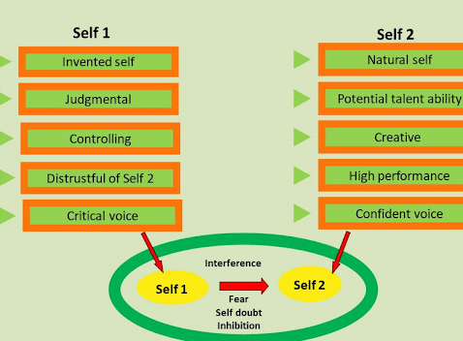
Coach and author Tim Gallwey presents an idea of the Self 1 & Self 2; Self 1 being the critical, judgmental voice that blames and shames and is usually caught up in ruminating about our past or worrying about our future. Self 2 is the authentic voice we probably had as a child which is accepting, curious, at ease with the world and present-moment focused (more on this in additional resources below).

Which of these best describes you?

N is also for... Notice what you Notice!
Going back to Session 2 on Attention, we start to see that, as we begin to notice the stories we tell ourselves, we can step back and see the pattern in our thinking - it's not just what we are thinking in that moment, it is the way we tend to think on a regular basis that forms the habit and the beliefs we have about ourselves (hard-wiring our brain to react in pre-established ways).
And remember the ACT model from session 2 as well; this awareness then brings choice - do we continue to allow this pattern or can we change the script and create a story that better serves us? We can then start to trust ourselves that we are investing our energy and focus in this new story.
Activities:
- Set an intention to pay attention.... to what you are saying to yourself, noticing how you react in certain situations, the words and phrases you use. Are they self-critical or self affirming? Consider this - how would you respond if one of your friends spoke to you in this way? Or how would they respond if you said to them what you say to yourself? Journal any insights and reactions - and what you might do differently, or, if you tend to be more positive, how you might do more of this.
- Think about yourself as you were 5 years ago. Reflect on the 'story' you believed then. What has changed and what has stayed the same? Capture your thoughts and insights in your journal. You can add an additional layer to this by thinking of yourself 5 years from now. What would you like the story to be?
Additional Resources:
- Check out this Ted Talk by Jodie Rodgers on The stories we tell ourselves.
- And this animation video on our critical inner voice highlights where it may come from and what we can do in response.
- Explore more about Tim Gallwey's Self I & Self 2 here here
