Restoring the Balance: A Mindful Approach to Managing Self
The following offers a summary of a mindfulness programme preciously delivered to University of Edinburgh Business School students. The programme covers 7 key topics, each of which introduces and explores mindfulness concepts (using the acronym BALANCE) and shares tools and resources which can help manage stress and overwhelm.
A is for Acceptance
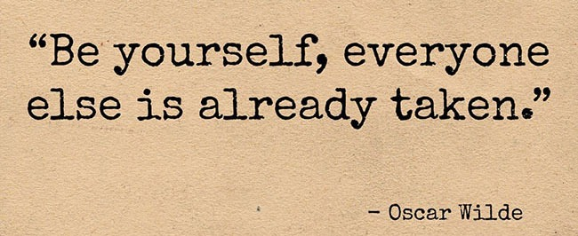
I learned about the power of acceptance the hard way! I am someone who was always a bit of a do-er, someone who saw challenges and problems as things to get sorted. So, when I was faced with something that I couldn't 'fix', what was my response? Resistance!
As a coach I have a strong belief in people's ability to affect changes in their lives - and we all have the potential to make great changes!
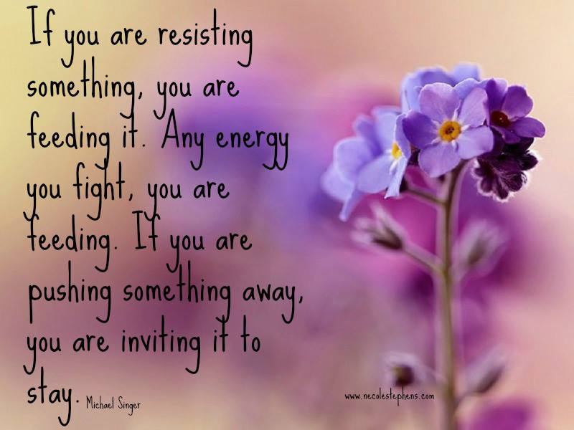
However, when it is something we cannot change (such as the behaviour or attitude of another person, events from our past or the death of someone close to us) we have a choice - we could resist the fact that we cannot change it or we can make a proactive choice to accept it. Mindful acceptance is not resignation, it is not passively giving up and, in doing so, being left with a defeated mindset. When we choose to accept, it is in making the choice itself that liberates us. And making this conscious choice leads to a sense of peace, a sense of stillness within us.
Acceptance is the willingness to experience things, and ourselves, as they really are, exploring the more challenging thoughts, emotions and situations with curiosity and compassion. If we push away what we find difficult we disconnect ourselves from that which makes us whole. Poet and author Vironika Tugaleva asked
"what if each time you experience an emotion you acknowledged it, accepted it and became curious about its message for you? Imagine how this could change your life. Imagine how heard, loved and honoured you would feel if you really listened to yourself"
It's a great statement, worth repeating...

"Imagine how this could change your life."
For one thing, imagine all the time, effort and energy you spend in pointless resistance (or, as the group identified; resentment, feeling guilty, being stuck, wasting time, damaging relationships, denial, avoidance....) . If you weren't engaged in these responses, what better use could you put your time, energy and focus to?
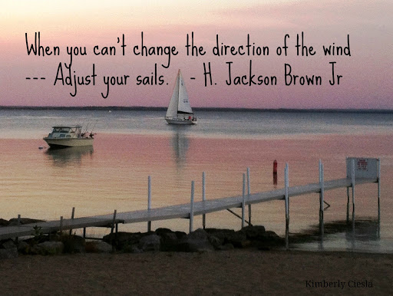
A is also for Attitude
Perhaps the best way to cultivate our understanding of acceptance is to consider the opposite - non-acceptance (which can be in the form of resistance, denial, judgement avoidance....), so rather than 'learning acceptance' it may be easier to think about how we let go of non-acceptance. We might also benefit from reflecting on our attitude - what we think and feel about the concept of acceptance itself? What does it mean to us?
If we view it as a negative (such as seeing it as resignation) how will that impact on our ability to practice it?
How we approach acceptance, therefore is key to how valuable it can be for us.
Activities
- Set a daily intention to practice acceptance. Start small, choosing one thing to focus on. For example, instead of getting agitated at how long the queue you are in is taking, focus on your breath and quietly connect with yourself. It wouldn't hurt to let a little smile develop too! Enjoy playing with this, applying an attitude of curiosity towards what comes up.
- Take a few moments to read the poem below, reflect on what it brings up for you and note down any questions, insights or actions in your journal.


Additional Resources:
check out this Ted-Talk with from slam poet Harry Baker and his unique perspective on self-acceptance - 'being happy being you!'
And this article from 'The Moment is Now' perfectly capture three key aspects of mindful acceptance.
And finally, listen to this short input on Mindful Acceptance by Jon Kabat-Zinn, which reinforces this idea of active, not passive acceptance.

