Restoring the Balance: A Mindful Approach to Managing Self
The following offers a summary of a mindfulness programme preciously delivered to University of Edinburgh Business School students. The programme covers 7 key topics, each of which introduces and explores mindfulness concepts (using the acronym BALANCE) and shares tools and resources which can help manage stress and overwhelm.

L is for Letting Go!


What are we holding onto that does not serve us ?
- This may be a belief or assumption we have about ourselves or someone else.
- We could be putting ourselves under undue pressure and expectation, creating unrealistic demands that often lead to sense of failure.
- It may be something we hold onto from our past that, by holding onto it - it holds onto us, preventing us from growing and developing.
- It may be a hurt or regret - something we may not be able to change (because it is in the past) but holding onto it just continues our suffering.
- It may be a mindset we have become ingrained in, stuck in a rut of self-limiting thought and subsequent behaviour.
- It could also be about other people - that toxic relationship that makes us feel bad about ourselves or the even the mindless throwaway comment someone made that we keep dwelling on.
- And our attitude or behaviour towards some people (based purely on our perception of them rather than what they have done) may be something we do not like to see in ourselves.
We have explored how practicing Being can allow us to be grounded in the present moment. Then we built on this, recognising that whatever we focus our Attention on grows. And we can build on this attention by becoming aware of what we are holding onto and what we could let go.
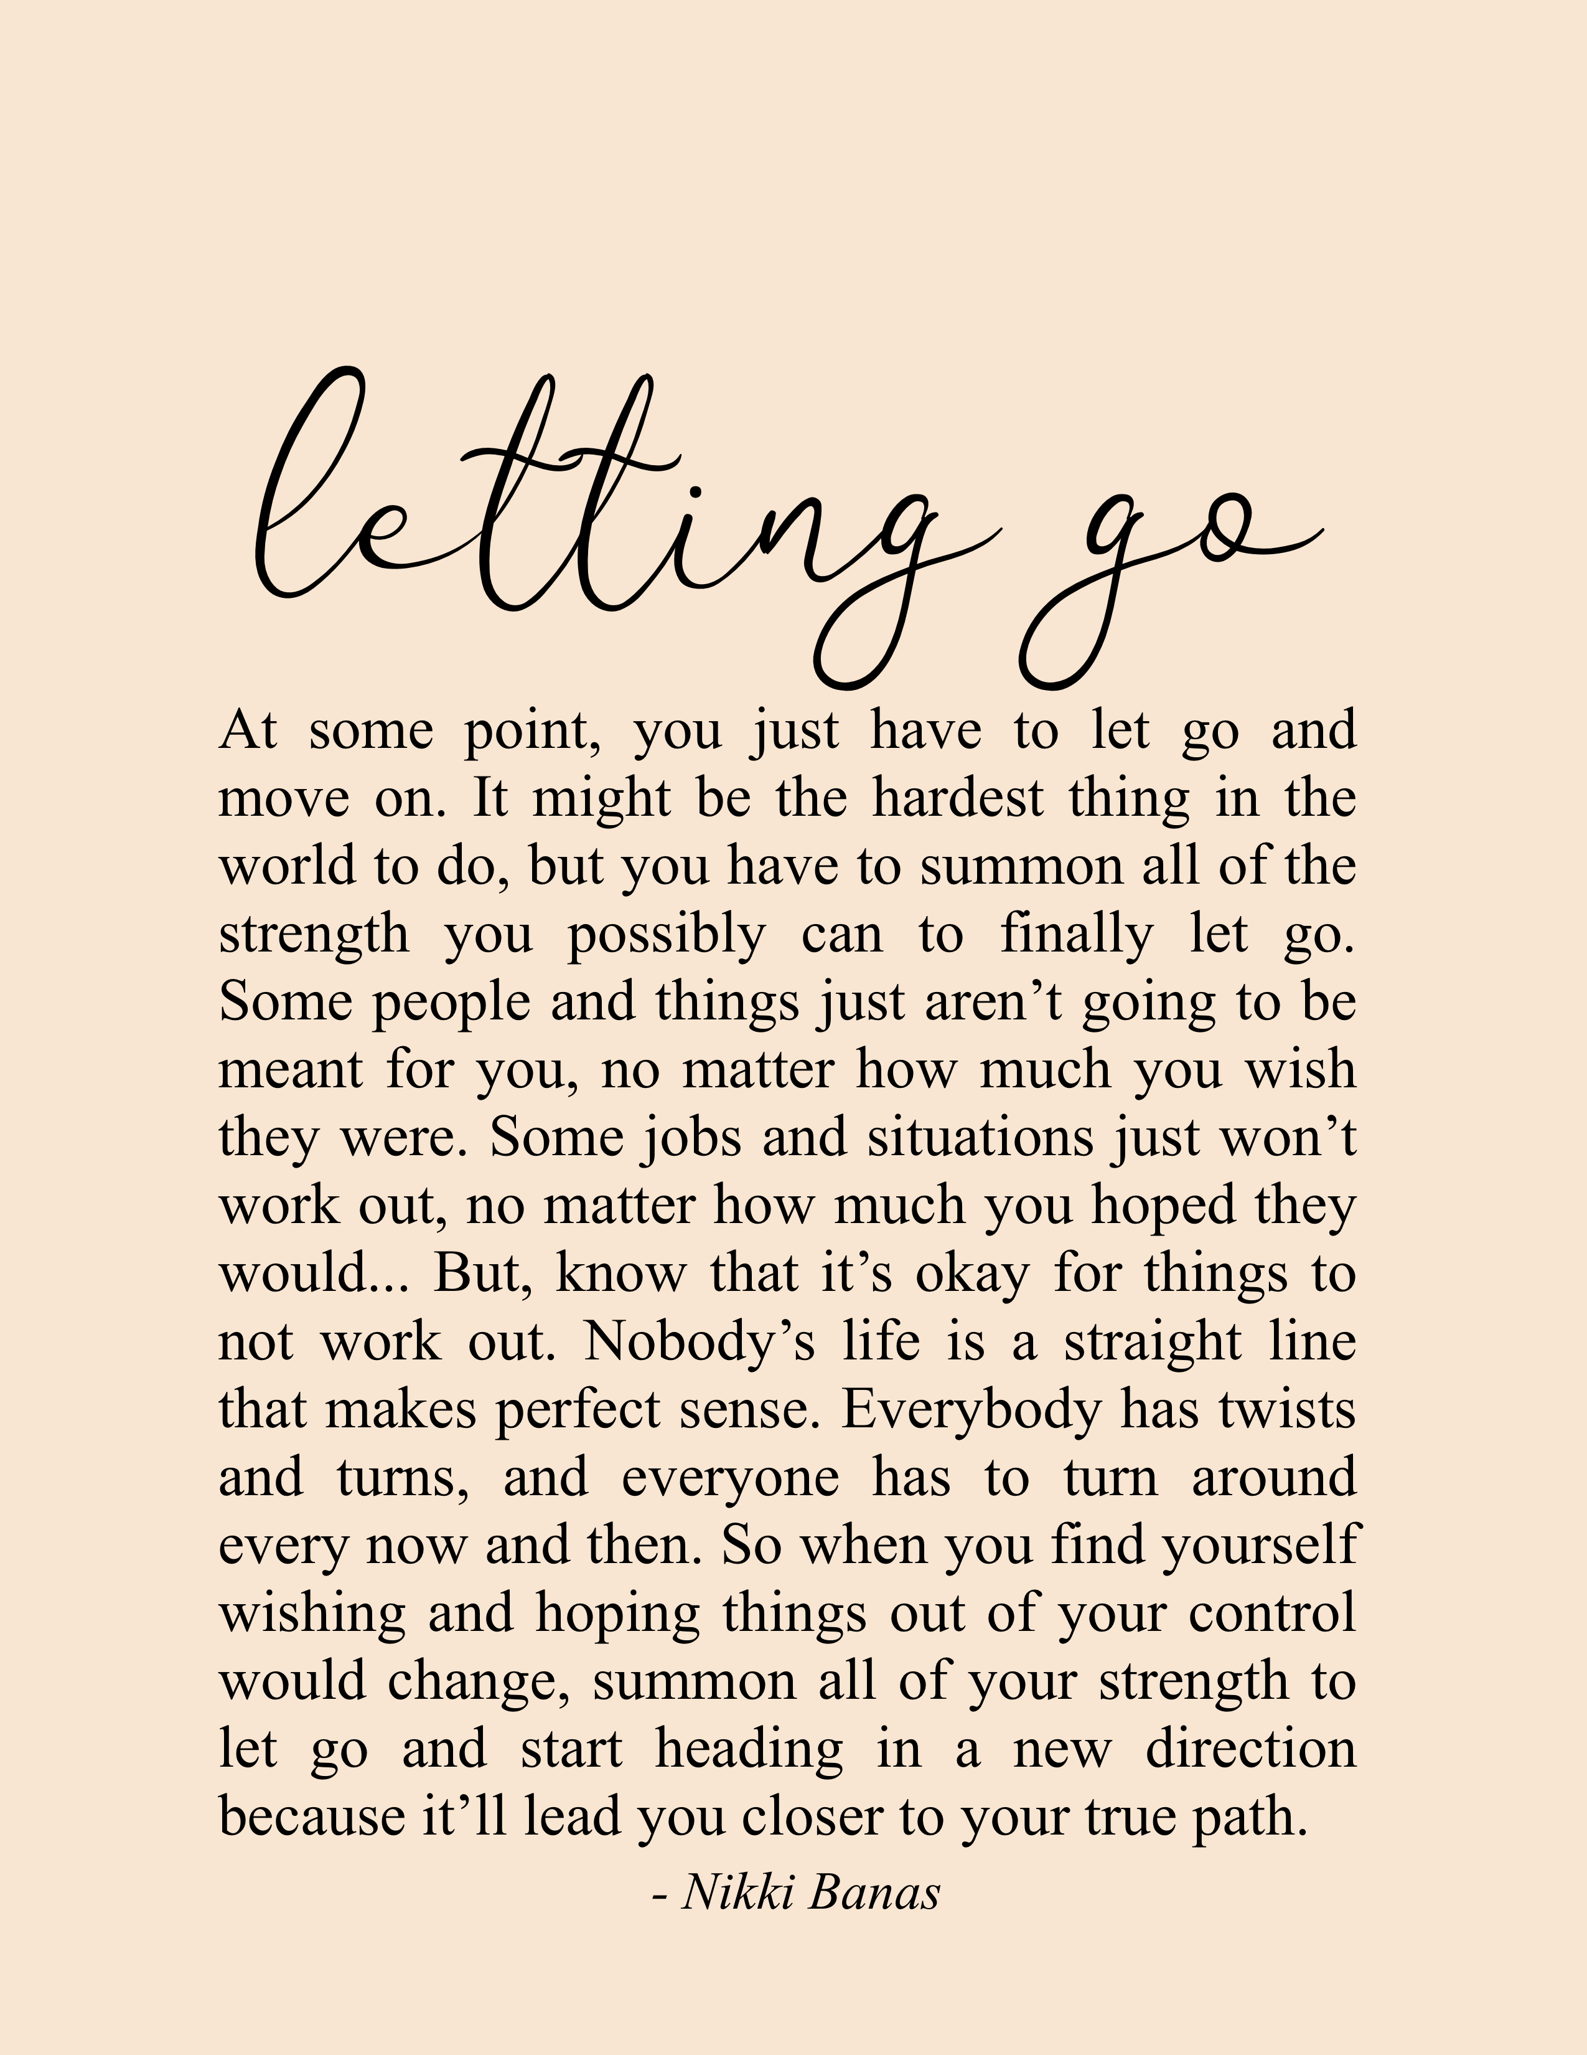
How do we let go?
The first step is in becoming aware that we may be holding onto things that are holding us back - a memory, a perception or an idea about ourselves that isn't particularly healthy. A resentment or negative attitude we have towards another that makes us the kind of person we don't want to be. Spend some time considering what you are holding on to.
Next, reflect on what impact holding onto this has on us.
It may also be useful to consider why we have held onto the things that don't serve us well? Is this simply a habit or is an underlying need being met?
Next, set an intention to release ourselves from whatever is holding onto us (check out last week's unit on Intention Setting). Some things will be easier to let go of than others, so we need to be patient with ourselves, especially if this is something we've held onto for a long time. Start small, focus on one thing and set the intention - you are not defined by your thoughts!
Finally, pay attention to how this feels and what thoughts you have. Notice any difference in your attitude as you experiment with letting go. Be curious about what you notice and don't forget to show yourself compassion. Letting go is a gentle release not a sudden offloading!
Let go and Allow
And think about what you fill the void with! If what you let go of has been a feature of your life for a while, it may return if we don't replace it with something more positive. As we let go, we create space for new things - new thoughts, new habits, new relationships - part of the intention setting can be around being open to and allowing better things into our lives.
L is also for Listening.... listening to ourselves and listening to others.
As we explore this idea of letting go to let come one of the key attributes that will serve us is our ability and capacity to listen!
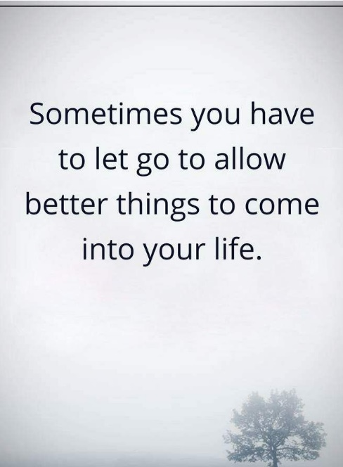
Later we will explore how our self-talk, the stories we tell ourselves can help or hinder us. But for now, simply practice listening to the inner conversations that go on all the time. Become familiar with what you are hearing and the assumptions that are perhaps forming as a result.
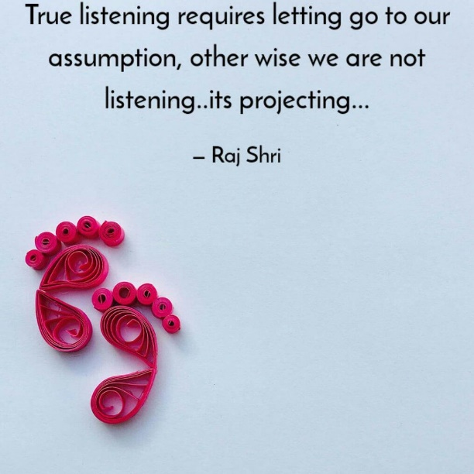
As we listen to ourselves, we become aware of the assumptions we may be holding onto, the (mis)-perceptions we've created and the beliefs we have developed as a result. We will explore this more deeply when we consider the Narrator but for now simply pay attention to what you hear - the internal dialogue going on constantly. Become familiar with what you are hearing and the assumptions that are perhaps forming as a result.
This is also about how we listen to others. To understand this, we need to switch it around! Think about a time when you were talking, and you got the sense the person you were speaking to was not listening. How did that feel?
This is something we are all guilty of. Perhaps we are simply waiting for the person to stop speaking so we can have our turn - to say what we've been thinking while we waited for them to finish. Or perhaps we want to jump in with our advice, confident that we have the answer to whatever dilemma this person is sharing?
If we can let go of this surface listening, let go of our need to 'fix' others, perhaps we will genuinely hear them. And in doing so, perhaps our deep listening - the sense of truly being heard is what will be of the greatest benefit to them.
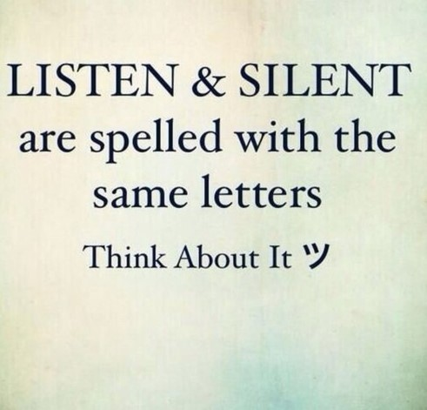
Activities
Reflect on and write down three things that you'd love to 'let go' off in your journal. You could visualise the act of letting go - get creative with this (check out this link for some ideas and exercises on letting go)
Additional Resources
Check out these articles for further exploration:
To Anyone Who Struggles With “Letting Go” by Jaime Ratliff
The Art of Letting Go by Susan Noonan

