Restoring the Balance: A Mindful Approach to Managing Self
The following offers a summary of a mindfulness programme preciously delivered to University of Edinburgh Business School students. The programme covers 7 key topics, each of which introduces and explores mindfulness concepts (using the acronym BALANCE) and shares tools and resources which can help manage stress and overwhelm.

B is for .... BEING!
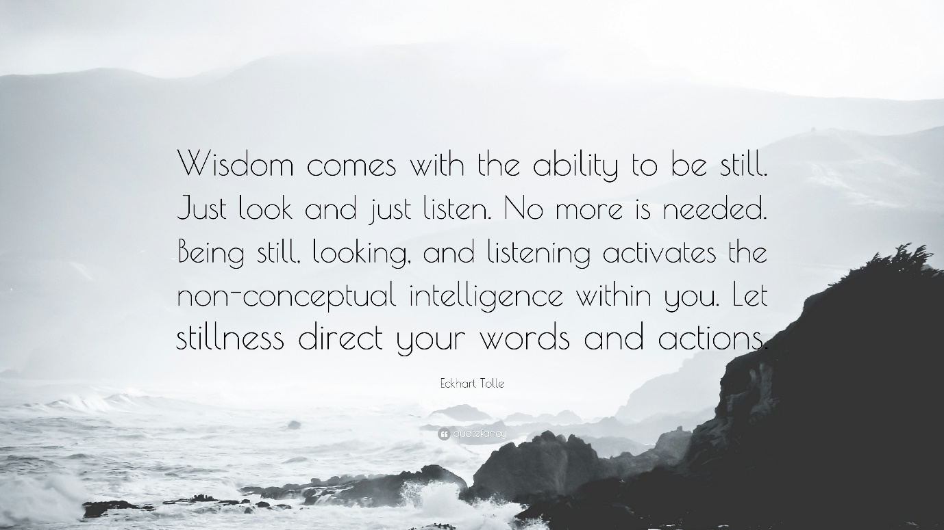
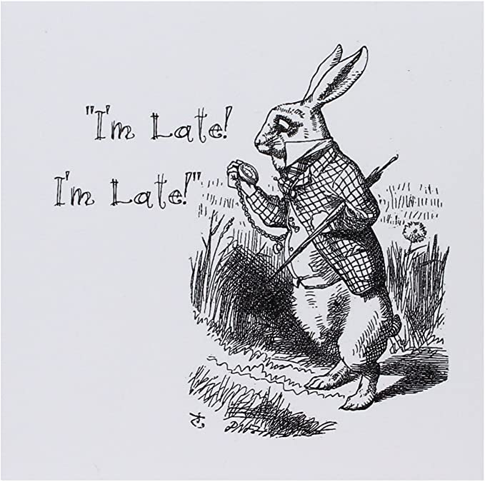
'Being' is the antidote to the busyness of constantly doing, which in turn can lead to feelings of overwhelm. It seems simple but have you ever tried to stop yourself from thinking, to switch off the noise inside your head? We have become so used to moving at a fast pace that it can be a challenge to slow down and the pressure to 'keep up' is all around us. There is actually a term for it now - it's called hurry sickness and it seems it is easy to catch. One simple test to know if you have hurry sickness - do you ever stand in a supermarket queue and start watching to see if the other lines are moving faster than yours? If the answer is yes then you have it! Another indicator is the number of times you check your watch or phone to see the time - only to do the same a few minutes later (just like the white rabbit in Alice in Wonderland, constantly chattering "I'm late, I'm Late...")
"I don't have the time or patience to simply do nothing"
Does that sound familiar?
The irony is that by giving ourselves a few moments each day to simply be, we actually enhance our ability to think, to become more focused and to feel that we are in control of rather than controlled by the pressure around us. Subsequently, we are able to achieve more that if we'd simply stayed in on the hamster wheel of busyness.
Be Here Now!
Being is also about connecting to the present moment and actually experiencing what is happening as it happens. Consider this for a moment:
How much of your time do you spend thinking over things that have happened in your past? It may be what happened yesterday or something that happened many years ago. We relive the past over and over again, replaying scenarios that we wish we could change or, alternatively, longing for that time when everything seemed better.
Or you may realise that your focus may be on the future, constantly thinking and perhaps worrying about the things that have not yet happened, in a state of perpetual planning for the day that may never come.
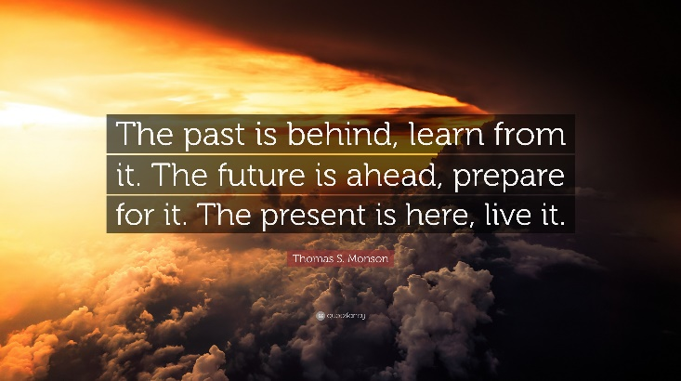
Now, both dwelling on the past and imagining the future are both perfectly natural things to do and both can be useful to us. There can be value in exploring our past - if we can use it to teach us. And anticipating our future can be a great way to harness our focus. However, if we spend too much time in either - at the expense of being in the present, then we risk missing out on connecting with ourselves at a deeper level, as we are and who we are right here and right now!
Activities
- B is also for Breathing. We use the breathe as an 'anchor' in many meditation practices. The reasons for this are simple - we always have our breathe with us and focusing on it is a great way to connect the mind and body and to connect with the present moment. Engage with the breath meditation in the downloads - I would encourage you to try and listen to this meditation regularly - every day if you can, for the next few days. Note down anything that arises in your journal.
- Journaling: The simple act of writing things down can be incredibly cathartic – it’s almost like emptying your jumbled mind onto paper. You can journal on anything – how you are feeling, what your day has been like, what you are grateful for. And it also gives you a record of the here and now, which when you revisit, is a valuable benchmark to what may have changed and what remains the same. Check out this articles on the benefits of journaling:
- 10 Journaling Tips to Help you Heal, Grow and Thrive by Loran Hills

- The STOP Tool: Try this technique when you are feeling overwhelmed:
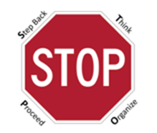
We start by stopping!
This handy tool from Tim Gallwey can be really useful in interrupting the busyness we so easily get caught up in. The first step, Stepping back, can also be the most difficult because we are usually triggered and under pressure. However, in doing so, we are able to move on to the next step and Think with a clear mind. Then we Organize our thoughts and decide how we will execute them. Finally, we actually Proceed to carry out what we have carefully thought through.
Try using this process to help you to manage the feeling of overwhelm and note down in your journal any insights.
If you are unsure of what else you could journal around, consider the following questions:
- If I was to stop and measure just how much time I spend thinking about either the past, the present or the future, what might I realise?
- If I started to recognise repetition in what I'm thinking about, what might this tell me about myself?
- What tangible difference could it make to me if I was able to pause the busyness and just be for a few moments each day?
- What am I grateful to have noticed or paid attention to today?
Additional Resources
- Check out this animated review of Eckhart Tolle's book the The Power of Now presented by Wisdom for Life. A number of key concepts are described including the idea of becoming observers of our thoughts, experiencing the power of living in the now, rather than the past or present and how 'surrendering' can be a transformative act. The video last 17 minutes so I'd encourage you to make yourself a drink and give yourself the space to absorb it.
- You could also read over this article on Hurry Sickness to find out more about what it is and how to respond.

